**Process Compliance Assessment Portal**

**Table of Contents**

1. **Document Control3**

1.1 Author By3

1.2 Approvals3

1.3 Version History3

**2) Introduction4**

3) Benefits of the tool5

**4) User Screen6**

**5) Homepage6**

5.1 Feeback7

5.2 Tools Overview7

5.3 FAQ8

**6) Dashboard9**

**7) Admin10**

7.1 Assessment10

7.1.1 Release Assessment11

7.1.2 Edit Assessment12

7.2 Add/Modify Roles13

7.3 Add/Update Survey & Sub-Survey Process14

**8) User15**

8.1 Super Admin15

8.1.1 Create Assessment16

8.1.2 Upload Question17

8.1.3 Edit Assessment18

8.1.4 View Assessment20

8.2 Project Co-ordinator20

8.2.1 View Assessment20

8.2.2 Save Response21

8.3 Process Consultant24

8.3.1 View Assessment24

8.3.2 Save Response25

**9) Summary Report27**

# Document Control

## 1.1 Author By:

By signing this document, I tender it for approval.

|  |  |  |
| --- | --- | --- |
| Delphin Sherly |  | Date: 19/06/2023 |

## 1.2 Approvals

|  |  |  |  |
| --- | --- | --- | --- |
| **Role** | **Print Name** | **Date** | **Version Number** |
| Team Lead | Delphin Sherly | 19/06/2023 | 1.0 |
| Approver | Shweta Rawat | 19/06/2023 | 1.0 |
| BA | Parnita Arora | 19/06/2023 | 1.0 |
| Business Owner | Shine Williams | 19/06/2023 | 1.0 |

## 1.3 Version History

|  |  |  |  |
| --- | --- | --- | --- |
| Effective Date | Version | Author | Description of Change |
| 16/05/2023 | 1.0 | Pa Parnita Arora | Creation of User manual for Process Compliance portal |

# Introduction

IT Process Compliance Assessment Tool will help to capture the compliance state of the IT Service Delivery teams. It defines different process maturity levels such as basic, managed, defined and optimized. This tool helps in assessing the current level of process maturity by evaluating processes against a set of best practices for each maturity level such as process definition, process measurement, process improvement and process integrations.

# Benefits of the tool

* IT Process Compliance tool helps to evaluate the maturity of business processes.
* It helps in reduction of manual efforts for process team.
* Reduces dependency on setting up calls.
* Data Integrity is maintained.

# User Screen

Step 1: Open a web browser and type in the application URL.

URL: <https://adminsupporttools.ciostage.accenture.com/processcompliance/#/>

Step 2: User is navigated to the login screen.

Step 3: User must enter the Accenture enterprise ID & password

Step 4: Click on Login option.

Step 5: The tool would validate the credentials and navigate the user to home screen.

# Homepage

* Once user clicks on Homepage, all the modules that are available for IT process will be displayed as follows:
* Home
* Dashboard
* Admin
* User
* Summary Reports
* Based on the access, user will be able to view or modify the respective module.
* Homepage will provide a slider which contain links to view the Tool Overview page and FAQs page.
* A Feedback option is provided to the user to submit their ratings and suggestions.
* Process compliance description will be displayed where user will get an option to view the assessment.
* Under Process compliance portal, On click of “click here to take assessement” button, User will be redirected to view all the assessment which are pending in their queue.
* Under E-Audit, On click of “click here to view portal” button, User will be redirected to E-Audit portal.
* A assessment calendar is provided where details of assessment that are completed and upcoming assessments will be displayed.

Once User click on home module, below screen will be displayed-

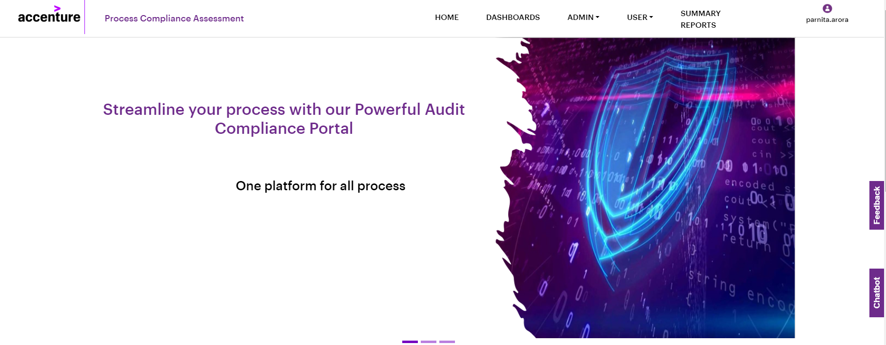

## 5.1 Feedback

* A button "Feedback" will be provided in top-corner of the page.
* On clicking the button, the user will be navigated to feedback page.
* On this page, option to rate this application through emoticons is provided.
* Once emoticons selected, the others will be disabled.
* When the user hover on the emoticons, the respective label will be displayed.
* A comment box will also be provided to enter feedback and suggestions. Once comments are provided, user can click on submit button and comments will be saved.

## 5.2 Tools Overview

* User will be provided option to view the workflow of assessment process.
* In the Process Workflow section, below are the four steps which are displayed in view mode only.
* **Step 1- Create assessment** - Super Admin creates the assessment and sets score for responses.
* **Step 2- Assign assessment** - Admin Assign the assessment to process owner and Project Coordinator.
* **Step 3- Take assessment** - Project Coordinator save responses for questions and submit the assessment for review.
* **Step 4- Review assessment** - Process consultant submit the assessment. Post review and assessment is marked as completed.

Highly Confidential - Internal Use Only

* In the Tool overview section, two links will be provided to view and download.
* **User Manual** – User will be provided an option to download the Process Compliance Assessment Portal User Manual.
* **Recording** - User will be provided an option to download the recording of the portal.

## 5.3 FAQ

* This page will contain set of frequently asked questions. Each question will have a slider, so when user clicks on the slider, the answer to respective question will be displayed.
* User will be able to search questions by entering keywords.
* If they enter any keyword, question related to that keyword will be displayed.

# Dashboard

* Dashboard is the graphical representation of all the ongoing assessment along with their current status.
* It shows three live score cards on top of the page.
* Compliance assessment taken- This will display number of compliance assessment taken from this portal.
* High maturity score- This score card will display the count of assessment which has very high maturity score i.e., greater than four.
* Average compliance level- This score card will display the average compliance level for all the assessments that are taken or completed.
* Based on the survey process, a graph is displayed as average maturity level process for all analysis area.
* Another graph is displayed as average compliance level process for all analysis area.
* A dropdown is provided to select assessment name and assessment id.
* Based on selection of assessment name and assessment id, a pie chart of assessment score will be displayed for all analysis area in percentage.
* On click of pie chart, another graph will be displayed as count of responses for each response category.
* At the bottom, respective compliance level and maturity level for the selected assessment will be displayed.

On click on Dashboard module, below screen will be displayed.

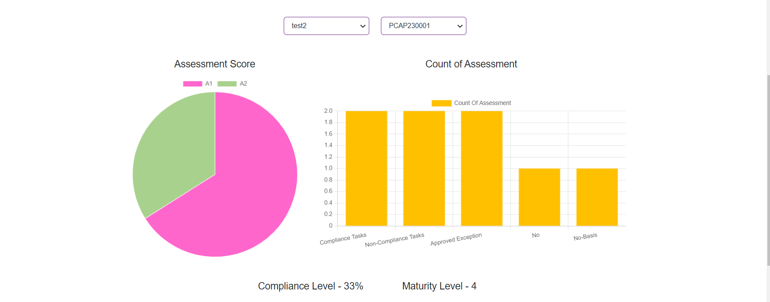

# Admin

Admin has the access to release the assessment for which checklist is created. The admin module is divided into two sub-modules :

* Assessment
* Add/Modify Roles

## 7.1 Assessment

This module is further divided into two sub modules.

* Release Assessment
* Edit Assessment

### 7.1.1 Release Assessment

Admin has the access to release the assessment for which checklist is created.

* On Selection of Assessment type, Survey process field will get auto populated.
* Based on the selection of Assessment type, Survey process and sub-survey process then name of the assessment field will get auto populated.

|  |  |  |
| --- | --- | --- |
| **Field Details** | **Mandatory** | **Validation** |
| Assessment type | Yes | Select from drop-down |
| Survey Process | Yes | Select from drop-down |
| Sub-Survey Process | Yes | Select from drop-down |
| Name of the assessment | Yes(Auto populated) | Enter the name of assessment like L3 Compliance Checklist - Sub survey Process name. |
| Process Consultant | Yes | Enter Enterprise ID of Process Consultant |
| Process Owner/Client POC | Yes | Enter Enterprise ID of Process owner/Client POC |
| Project Co-Ordinator | Yes | Enter Enterprise ID of Project Co-ordinator |
| Department of Project Co-Ordinator | Yes | Should be alphabets. |
| Unit of Project Co-Ordinator | Yes | Enter unit of Project POC |
| Team of Project Co-Ordinator | Yes | Enter team of Project POC |
| Organization/Client Name | Yes | Should be alphabets. |
| Assessment Start Date | Yes | Selected from calendar drop down. |
| Assessment End Date | Yes | Selected from calendar drop down. |

* Once all the data is entered, user has to click on Submit button and the assessment will be released to respective POCs.

Once user clicks on Admin- Release Assessment module, below screen will be displayed.

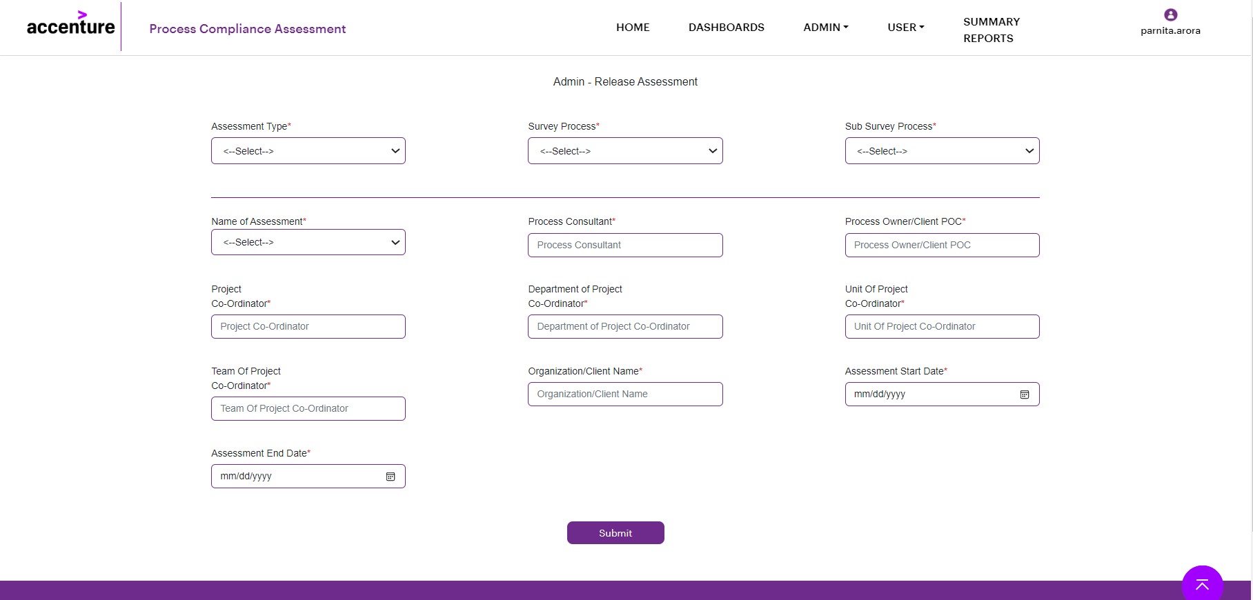

### 7.1.2 Edit Assessment

Upon clicking **Edit Assessment,** user will be able to edit or modify the assessment.

* On selecting of survey process, other fields will get auto populated like Sub-survey process, Assessment name and Assessment ID.
* If user picks up any date which is less than current date then a validation message will be displayed, " Please select valid date."
* When user select Survey process, Sub-Survey process, Assessment name and Assessment id, below field values will get auto populated.
* All the below fields become editable only when user click on edit icon.

**Field Level Specification:**

|  |  |  |
| --- | --- | --- |
| **Field Details** | **Mandatory** | **Validation** |
| Assessment type | Yes | Select from drop-down |
| Survey Process | Yes | Select from drop-down |
| Sub-Survey Process | Yes | Select from drop-down |
| Name of the assessment | Yes (Auto populated) | Select from drop-down |
| Assessment ID | Yes | Assessment ID will always be unique. The Assessment Id will start from PCAP000000. |
| Process Consultant | Yes | Enter Enterprise ID of Process Consultant |
| Project POC | Yes | Enter Enterprise ID of Project POC |
| Department of Project POC | Yes | Should be alphabets. |
| Unit of Project POC | Yes | Enter unit of Project POC |
| Team of Project POC | Yes | Enter team of Project POC |
| Organization | Yes | Should be alphabets. |
| Assessment Start Date | Yes | Selected from calendar drop down. |
| Assessment End Date | Yes | Selected from calendar drop down. |

When User clicks on the following buttons corresponding operations will be performed -

1. **View**- On click of View button, user can be able to view all the selected details.
2. **Edit**- On click of Edit button, user will be able to modify the assessment details.
3. **Submit** – After completing all the modifications once user will click on Submit button and all changes will be saved for respective assessment template.

Once user clicks on sub-module “Edit Assessment” below screen will be displayed:

## 7.2 Add/Modify Roles

The purpose of this module to add or modify the roles of the user.

**Steps to be followed by the user:**

* If user select the checkbox as “Yes, User is a part of Accenture” then employee name text field and role dropdown field will get populated.
* The role field display values as “Super-Admin” "Admin" "Process Consultant" and "Project Co-Ordinator".
* Enter the enterprise id and select role from dropdown, then click on add button.
* By default, all the roles added by the user are displayed in a table grid with column names as Employee Name, Role, Created On, Created By, Updated By and Updated On.
* **ADD** – After entering all mandatory details, on click of Add button, a success message will be displayed, "Details added successfully". After that clicking on ‘ok’ button, added details will be displayed in a table grid.
* User will be able to edit, update, cancel or delete all the details mentioned in the grid which become editable or deleted.
* If user click on any record from the table grid, he has to click on edit icon. On click of edit icon role will become editable and details get updated.
* On click of update icon, a pop message will be displayed, “The Role is updated by user”.
* User will also get an option to search at top of the table grid.

Once user click add/modify role module, below page will be viewed.

## 7.3 Add/Update Survey & Sub-Survey Process

The purpose of this module is to add or update the survey and sub-survey process.

* Two tabs will be provided to add or update the survey and sub-survey process.
* On selection of Survey process tab, Survey process text field and add button is provided.
* By default, all the survey process added by the user are displayed in a table grid with column names as Survey process, Role, Added On and Added By.
* **ADD** – After entering all mandatory details, on click of Add button, a success message will be displayed, "Details added successfully". After that clicking on ‘ok’ button, added details will be displayed in a table grid.
* User will be able to edit, update or cancel all the details mentioned in the grid.
* If user click on any record from the table grid, he has to click on edit icon. On click of edit icon role will become editable and details get updated.
* On click of update icon, a pop message will be displayed, “The Role is updated by user”.

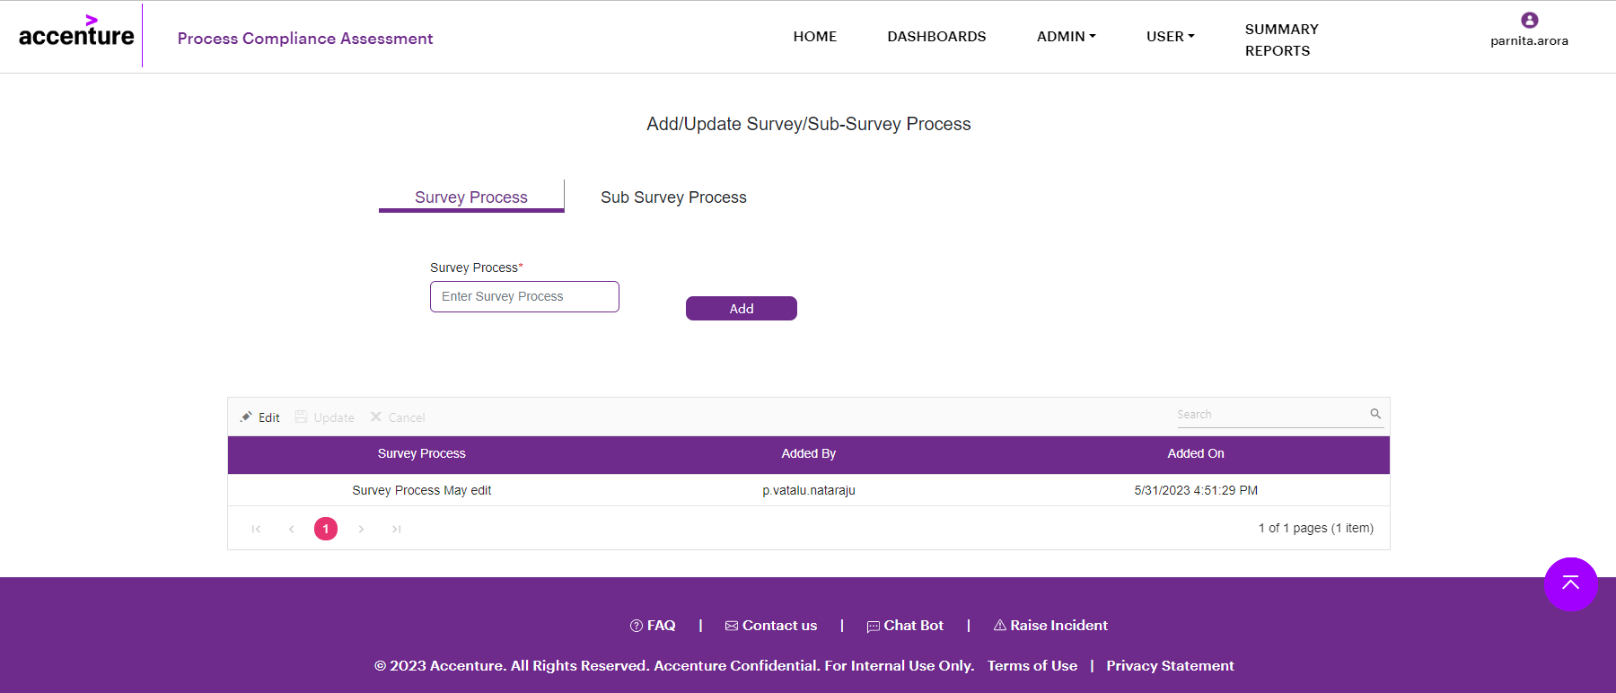

* On selection of Sub-Survey process tab, Survey process dropdown field, Sub-survey process text field and add button is provided.
* By default, all the survey process added by the user are displayed in a table grid with column names as Survey process, Sub-Survey process, Added On and Added By.
* **ADD** – After entering all mandatory details, on click of Add button, a success message will be displayed, "Details added successfully". After that clicking on ‘ok’ button, added details will be displayed in a table grid.
* User will be able to edit, update or cancel all the details mentioned in the grid which become editable or deleted.
* If user click on any record from the table grid, he has to click on edit icon. On click of edit icon role will become editable and details get updated.
* After that on click on update icon, a pop message will be displayed, “The Survey Process and Sub-Survey Process is updated by user”.

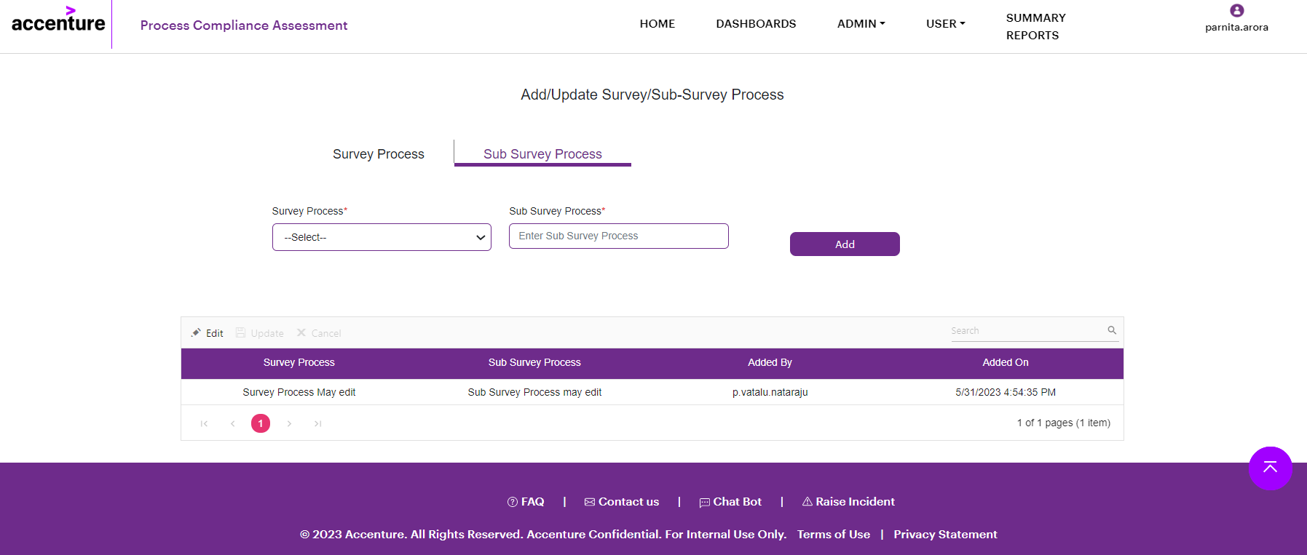

# User

Below user will be access the portal.

* Super Admin- Super admin create the check list.
* Project Co-Ordinator- Project coordinator takes the assessment.
* Process Consultant- Process consultant review the checklist.

## 8.1 Super Admin

Super admin has the access to create the assessment, upload the questions, and view or modify the assessment. This module contains three sub-modules:-

### 8.1.1 Create Assessment

This module helps the super admin to create the assessment.

* On selecting of Assessment type, other fields will get auto populated like Survey Process, Sub-Survey process and Assessment name.
* A dropdown field is provided to select score responses.
* The response/score field display values as “Yes/1” " Partial/0.5" " Approved exception/0.3" "No/0" and "No-Basis-0".
* User needs to select all the responses value.
* User will be allowed to add analysis area along with weightage.
* Once user click on add icon, User can add multiple analysis area and response for any specific survey and sub-survey process added.
* The weightage added for all the analysis area should be 100%. If weightage is less than or more than 100% for all the analysis area then a notification message will get displayed, “Please enter the correct weightage”.

**Field Level Specification:**

|  |  |  |
| --- | --- | --- |
| **Field Details** | **Mandatory** | **Validation** |
| Select Assessment type | Yes | Select from drop-down |
| Add Survey Process | Yes(Auto populated) | Select from drop-down |
| Add Sub-Survey Process | Yes(Auto populated) | Select from drop-down |
| Add Assessment Name | Yes | Enter the assessment name |
| Add Analysis Area | Yes | Enter the analysis area |
| Weightage | Yes | Weightage should maintain 100% |

Once user click on UseràSuper AdminàCreate assessment, below screen will be displayed.

Once user enter all the mandatory fields and click on submit button, then assessment is created.

### 8.1.2 Upload Questions

* Super Admin has the access to upload question for specific survey process and sub-survey process.
* On selection of Assessment type, other fields will get populated.
* A dropdown field is provided to select Assessment type, Survey process, Sub-Survey process, Assessment name, Analysis area and Question template.
* Based on selection of analysis area, question will get uploaded for that respective category.
* User can download the template, enter the data and save it to the desktop, browse it and upload it by clicking on upload button.
* Once all the data entered, user needs to click on submit button to upload the questions.
* A clear button is provided to set all the filters values to default.
* View uploaded data slider is available to view the uploaded questions.
* By default, all the survey process added by the user are displayed in a view uploaded slider with column names as Assessment Type, Survey process, Sub-Survey process, Analysis area and Total questions.
* On click of any particular row, a pop box will appear to view the uploaded question.
* Once user has uploaded questions for all Analysis area, they will click on Create checklist button and the assessment template is created.

**Field Level Specification:**

|  |  |  |
| --- | --- | --- |
| **Field Details** | **Mandatory** | **Validation** |
| Assessment type | Yes | Select from drop-down |
| Survey Process | Yes(Auto populated) | Select from drop-down |
| Sub-Survey Process | Yes(Auto populated) | Select from drop-down |
| Assessment Name | Yes | Select from drop-down |
| Analysis Area | Yes(Auto populated) | Select from drop-down |
| Question Template | Yes | Select from drop-down |

Once user click on UseràSuper AdminàUpload Question, below screen will be displayed.

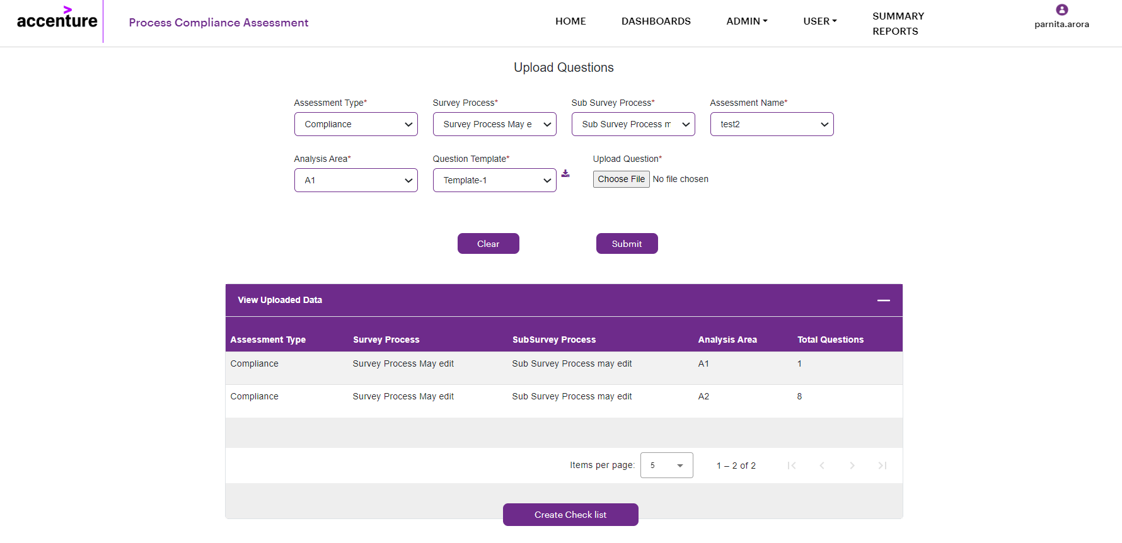

### 8.1.3 Edit Assessment

User will get an option to modify the assessment.

* By default, all the assessment entered by the user are displayed in a table grid with column names as Assessment name, Created by, Created date, Updated by, Last updated on and Actions.
* Once user click on edit icon, two tabs will be displayed one is “Edit question” and other is “Edit Analysis area”.
* In tab “Edit Question”, if user click on edit icon a pop window will appear to display the questions.

Once user click on Edit Assessment, below screen will be displayed.

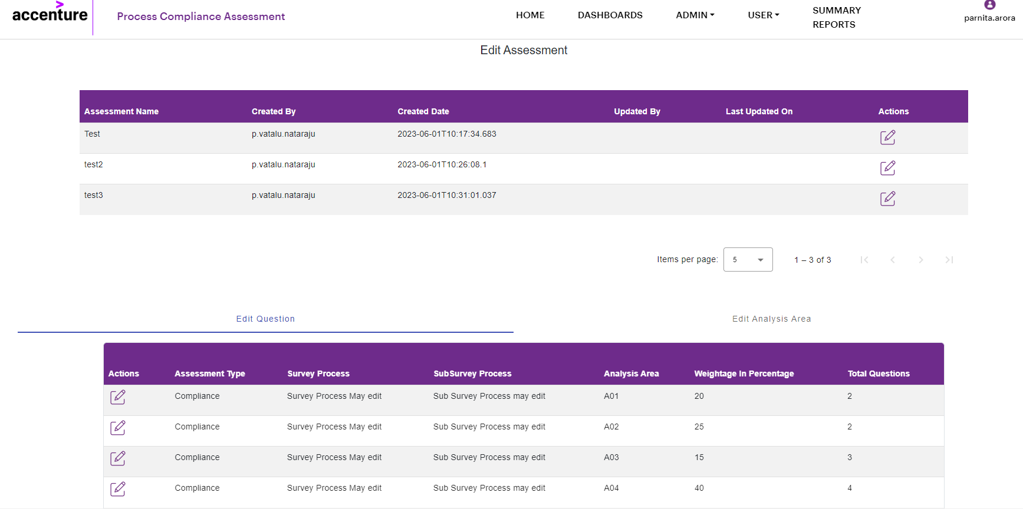

In Edit Question tab, if any user clicks on edit icon, below screen will appear. User will get an option to add, save or clear the question.

* In tab “Edit Analysis Area”, By default, all the assessment entered by the user are displayed in a table grid with column names as Action, Assessment type, Survey Process, Sub-Survey Process, Analysis area, Weightage in Percentage.
* The total weightage should always be 100%.
* User will also get an option to modify the column of Analysis area and Weightage in percentage.

Below is the screen to view the Edit Analysis Area tab .

When User clicks on the following buttons corresponding operations will be performed -

1. **Save**- After all the modification done, user will click on save button to save the changes.
2. **Delete**- On click of Delete button, all the entered data will be deleted.

### 8.1.4 View Assessment

* User will be able to view the assessment details entered by user along with status in a table grid.
* By default, all the details entered by the user are displayed in a table grid with column names as Assessment name, Assessment ID, Last Modified By, Last Modified Date, Status and Actions.
* On click “Upload question” link, user will be redirected to upload questions module.

On click on View assessment, below screen will be displayed.

## 8.2 Project Co-Ordinator

Project coordinator will get an option to review the assessment and verify all the details after reviewing they will be able to modify any particular record. Based on the assessment, user will get an option to add comments if any and save the response.

This module contains the two sub modules.

* View Assessment
* Save Response

### 8.2.1 View Assessment

* User will be able to view the assessment details entered by user along with status in a table grid.
* By default, all the entered details by the user are displayed in a grid with column names as Assessment name, Assessment ID, Last modified date, last modified by, status and actions.
* All the values will be auto populated from Admin module.
* By clicking ‘Take Assessment’ link, user will be redirected to save response page.

Once user click on Project coordinatoràView assessment below page will be displayed.

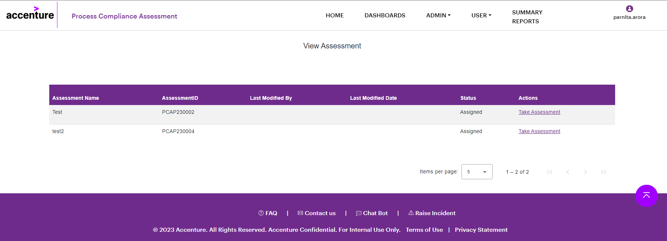

### 8.2.2 Save Response

* User will capture all the responses.
* All the field values will get auto populated from Adminà Release assessment module which are non-editable fields.
* Below Compliance level in percentage and Maturity score will be displayed.
* Whenever any user clicks on ‘View Summary’ button, a pop-up box will appear and graph report will be displayed based on the responses captured by the user.
* The first graph will show the percentage of questions completed.
* A graph will display count as well as percentage of questions completed and open.
* If any user clicks on any particular analysis area, another graph will be displayed which will show the count of all responses captured for the selected analysis area.
* In Analysis Area section, all the analysis areas will be displayed in tab.

**Field Level Specification:**

|  |  |  |
| --- | --- | --- |
| **Field Details** | **Mandatory** | **Validation** |
| Project Co-ordinator | Yes (Auto populated) | Non-editable field |
| Department of Project Co-ordinator | Yes (Auto populated) | Non-editable field |
| Unit of Project Co-ordinator | Yes (Auto populated) | Non-editable field |
| Team of Project Co-ordinator | Yes (Auto populated) | Non-editable field |
| Organization/Client name | Yes (Auto populated) | Non-editable field |
| Assessment Name | Yes (Auto populated) | Non-editable field |
| Process Consultant | Yes (Auto populated) | Non-editable field |
| Assessment ID | Yes (Auto populated) | Non-editable field |
| Project Owner/Client POC | Yes (Auto populated) | Non-editable field |
| Assessment Start date | Yes (Auto populated) | Non-editable field |
| Assessment End date | Yes (Auto populated) | Non-editable field |

Once user click on “Take Assessment” link, below screen will be displayed.

* In each tab, a table will be displayed with following columns- Questions, Sampling required, Compliance leave, Artifacts, and comments.
* Question- A set of questions will be displayed.
* Sampling required- On click, values will be able to select option as yes or no.
* Compliance Level- Based on the assessment template, value will be auto populated from Super Admin module.
* Artifacts- If any artifacts required, user has to choose and upload it.
* Comments- User can be able to add comments if required.
* Once user entered all mandatory fields in the table i.e., Sampling Required and compliance level and click on save button.
* On click of Submit button, assessment will get submitted.

Once User clicks on View Summary Button, below screen will get displayed.

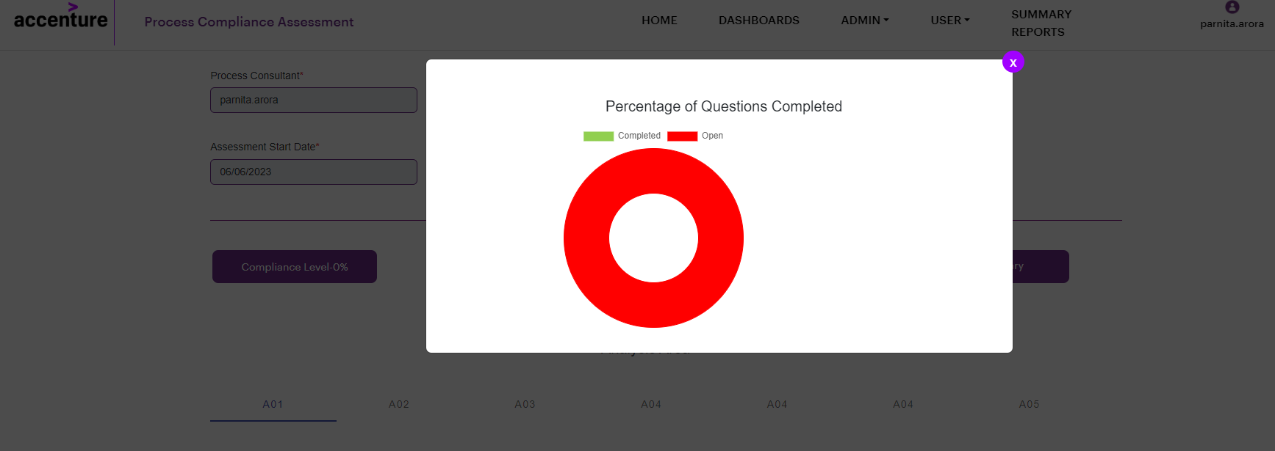

When User clicks on the following buttons corresponding operations will be performed -

1. **View Summary**– On click of View Summary, a pop window will appear, and graph will be displayed based on responses captured by user.
2. **Save**- Once all the mandatory details are entered by user, on click of Save button, a validation message will be displayed, “Details saved successfully". On click on ok, Assessment get saved.
3. **Submit** – On click of Submit button, a pop-up message will get displayed, “Are you sure you want to submit the assessment?” On click on ok, user will re-direct to Process Consultant—>View Assessment page.

## 8.3 Process Consultant

Project consultants will get an option to review the assessment. They will be able to modify or update details if required. Based on the assessment, they need to provide recommendation/suggestions and save the response. This module is divided into two sub modules.

* View Assessment
* Save Response

### 8.3.1 View Assessment

* This module shows the details of the assessment along with status.
* In Project consultantà Save response, once user click on submit button, auto-populated data will be displayed.
* By default, all the entered details by the user are displayed in a grid with column names as Assessment name, Assessment ID, Last modified date, last modified by, status and actions.
* All the entered values will get auto populated from Admin module.
* By clicking take assessment link, user will be redirected to save response page.

Once user click on Project consultantàView assessment below page will be displayed.

### 8.3.2 Save Response

* Project consultant will review the assessment.
* All the entered field will get auto populated from admin module which are non-editable.
* Below Compliance level in percentage and Maturity score will be displayed.
* Whenever any user clicks on ‘View Summary’ button, a pop-up box will appear, and graph report will be displayed based on the responses captured by the user.
* The first graph will show the percentage of questions completed.
* A graph will display count as well as percentage of questions completed and open.
* If any user clicks on any particular analysis area, another graph will be displayed which will show the count of all responses captured for the selected analysis area.
* In Analysis Area section, all the areas will be displayed in tab.
* In each tab, a table will be displayed with following columns- Actions, Questions, Sampling required, Compliance level, Artifacts, and comments.
* User will able to view or modify all the fields which are provided in the table.
* On click on edit icon, user will able to modify the Sampling required and Compliance level field.
* A Recommendations/Suggestions text box is provided to enter the suggestions.

**Field Level Specification:**

|  |  |  |
| --- | --- | --- |
| **Field Details** | **Mandatory** | **Validation** |
| Project Co-ordinator | Yes (Auto populated) | Non-editable field |
| Department of Project Co-ordinator | Yes (Auto populated) | Non-editable field |
| Unit of Project Co-ordinator | Yes (Auto populated) | Non-editable field |
| Team of Project Co-ordinator | Yes (Auto populated) | Non-editable field |
| Organization/Client name | Yes (Auto populated) | Non-editable field |
| Assessment Name | Yes (Auto populated) | Non-editable field |
| Process Consultant | Yes (Auto populated) | Non-editable field |
| Assessment ID | Yes (Auto populated) | Non-editable field |
| Project Owner/Client POC | Yes (Auto populated) | Non-editable field |
| Assessment Start date | Yes (Auto populated) | Non-editable field |
| Assessment End date | Yes (Auto populated) | Non-editable field |
| Recommendation/Suggestions | Yes | Enter the recommendation/suggestions |

Once user click on take assessment link, it will be redirected to save responses module

Once user click on view summary button, below two graphs will be displayed.

When User clicks on the following buttons corresponding operations will be performed -

1. **View Summary**– On click of View Summary, a pop window will appear, and graph will be displayed based on responses captured by user.
2. **Save**- Once all the mandatory details are entered by user, on click of Save button, a validation message will be displayed, “Details saved successfully". On click on ok, Assessment get saved.
3. **Submit** – On click of Submit button, a pop-up message will get displayed, “Are you sure you want to submit the assessment?” On click on ok, Assessment will get submitted.

# Summary Report

* Once user select two mandatory fields- Year and Assessment type and then click on view button, entered details will get auto populated in the table grid.
* All the entered details by the user are displayed in a table with column names as Assessment name, Assessment ID, Project Co-Ordinator, Project Owner/Client POC, Department of Project Co-Ordinator, Unit of Project Co-Ordinator, Team of Project Co-Ordinator, Organization/Client Name, Process Consultant and Assessment Date.
* If user click on any particular record, user will be able to view the analysis area.

**Field Level Specification:**

|  |  |  |
| --- | --- | --- |
| **Field Details** | **Mandatory or Auto populated** | **Validation** |
| Role | No | Select from dropdown |
| Year | Yes | Select from dropdown |
| Assessment Type | Yes | Select from dropdown |
| Survey Process | No | Select from dropdown |
| Sub-Survey Process | No | Select from dropdown |
| Name of Assessment | No | Select from dropdown |
| Assessment ID | No | Select from dropdown |

When User clicks on the following buttons corresponding operations will be performed -

1. **Clear**– Once Clear button is clicked, all the filters will be set to default.
2. **View**- All the assessment details will be displayed in grid based on filter selection.
3. **Export** – All the assessment details will be exported to excel based on filter selection.

On click on Summary Reports, below page will be displayed.

